Day 1
1. Introduction to RAG (Retrieval-Augmented Generation)
What is RAG?
Retrieval-Augmented Generation (RAG) is an advanced AI approach that integrates retrieval systems with generative models. It allows AI to produce more accurate, context-aware responses by fetching relevant external knowledge before generating text.
How Does RAG Work?
- Retrieval Phase:
  - Queries external knowledge bases or databases to fetch the most relevant information.
  - Sources include document repositories, websites, or vector databases.
- Generation Phase:
  - Uses a generative AI model to incorporate the retrieved context and create a meaningful response.
  - Models like GPT or T5 are often used.
Applications:
- Question Answering Systems.
- Real-time Chatbots.
- Content Generation for Specific Domains.

2. Understanding Vectors in AI
What is a Vector?
A vector is a mathematical representation of data in numerical form. In AI, vectors are commonly used to represent words, sentences, or images in a machine-readable way.
Why Are Vectors Important?
Vectors simplify complex data, making it easier for models to:
- Identify patterns.
- Measure similarities.
- Perform efficient computations.
Real-World Examples:
- In Text: Representing words like “king” and “queen” in a way that captures their semantic relationship.
- In Images: Encoding pixel data to compare similar images.
3. Embedding Models
What is an Embedding Model?
An embedding model transforms input data into a dense vector space where similar items are close together. These models aim to preserve semantic relationships.
Types of Embedding Models:
- Text Embeddings:
  - Tools: BERT, DistilBERT, GPT.
  - Use Case: Finding similar sentences or concepts.
- Image Embeddings:
  - Tools: ResNet, CLIP.
  - Use Case: Visual search or object recognition.
Key Benefits:
- Reduced data dimensionality.
- Captures meaningful patterns.
- Enables similarity searches in large datasets.
4. Ollama: A Custom Concept or Tool
Ollama may refer to an AI-related framework or application. While not widely recognized, its use could be specific to:
- Managing AI models.
- Running embeddings-based workflows.
- Custom tooling in an AI pipeline.
For clarity, ensure your project documentation specifies its exact purpose.
5. Distance Metrics in AI
Cosine Distance:
- Measures the similarity between two vectors based on the angle between them.
- Formula: Cosine Similarity=A⋅B∥A∥∥B∥\text{Cosine Similarity} = \frac{\text{A} \cdot \text{B}}{\|\text{A}\| \|\text{B}\|}Cosine Similarity=∥A∥∥B∥A⋅B​
Applications:
  - Text similarity.
  - Clustering and classification.
Euclidean Distance:
- Calculates the straight-line distance between two points in space.
- Formula: Distance=∑i=1n(xi−yi)2\text{Distance} = \sqrt{\sum_{i=1}^n (x_i - y_i)^2}Distance=i=1∑n​(xi​−yi​)2​
Applications:
  - Measuring absolute differences.
  - Used in image comparison and clustering.

6. Chroma Database
What is Chroma?
Chroma is a vector database designed to store and query vector embeddings. It supports efficient similarity searches and embedding management.
Features:
- High scalability for large datasets.
- Fast querying of similar vectors.
- Integrations with AI and machine learning frameworks.
Use Case:
For a chatbot, embeddings of frequently asked questions can be stored in Chroma. When a user asks a question, the most relevant embeddings are retrieved and used to generate a response.

7. Embedding Code Snippet Explanation
This code demonstrates how to use the Transformers library for generating embeddings:
Python
Codeing:
from transformers import AutoTokenizer, AutoModel
import torch
# Load pre-trained model and tokenizer
model_name = "distilbert-base-uncased"
tokenizer = AutoTokenizer.from_pretrained(model_name)
model = AutoModel.from_pretrained(model_name)

def word_to_vector(word):
inputs = tokenizer(word, return_tensors="pt", padding=True, truncation=True)
with torch.no_grad():
outputs = model(**inputs)
word_vector = outputs.last_hidden_state.mean(dim=1).squeeze().numpy()
return word_vector

word = "what is the use of program data"
vector = word_to_vector(word)
print(f"Vector for the word '{word}':\n{vector}")
Explanation:
- Model Loading:
  - Loads the distilbert-base-uncased model, a lightweight version of BERT.
- Tokenization:
  - Splits the input text into tokens for processing.
- Embedding Generation:
  - Extracts vector representations from the model’s outputs.

8. Using the Llama API
Example API Request:
Bash
codeing:
curl -X POST http://localhost:11434/api/chat \
-H "Content-Type: application/json" \
-d '{
"model": "llama3.2:3b",
"messages": [
{"role": "user", "content": "What is the capital of France?"}
]
}'
API Workflow:
- Request:
- Sends a question to the Llama model.
- Response:
  - Retrieves the answer: “The capital of France is Paris.”
- Performance Metrics:
  - The system logs key details like evaluation duration, model load time, etc.

9. Importance of System Environment Variables
System environment variables are configurations used by operating systems to control the behavior of applications.
Key Variables:
PATH:
  - Defines locations of executables.
API_KEYS:
  - Stores sensitive keys securely for authentication.
Why Are They Important in AI?
- Configures model paths and database connections.
- Ensures consistency across different environments

By combining the concepts above:
- Use embedding models to process and vectorize data.
- Store these vectors in a Chroma Database.
- Leverage RAG to enhance generative AI systems.
- Apply Cosine and Euclidean distances for similarity searches.

# Example usage
word = "what is the use of program data"
vector = word_to_vector(word)
print(f"Vector for the word '{word}':\n{vector}"
ml@pop-os:~$ curl -X POST http://localhost:11434/api/chat -H "Content-Type: application/json" -d '{
"model": "llama3.2:3b",
"messages": [
{
"role": "user",
"content": "What is the capital of france?"
}
]
}'

Vector model

{"model":"llama3.2:3b","created_at":"2024-12-02T06:51:02.147439431Z","message":{"role":"assistant","content":"The"},"done":false}
{"model":"llama3.2:3b","created_at":"2024-12-02T06:51:02.23235997Z","message":{"role":"assistant","content":" capital"},"done":false}
{"model":"llama3.2:3b","created_at":"2024-12-02T06:51:02.317344812Z","message":{"role":"assistant","content":" of"},"done":false}
{"model":"llama3.2:3b","created_at":"2024-12-02T06:51:02.402500196Z","message":{"role":"assistant","content":" France"},"done":false}
{"model":"llama3.2:3b","created_at":"2024-12-02T06:51:02.487580605Z","message":{"role":"assistant","content":" is"},"done":false}
{"model":"llama3.2:3b","created_at":"2024-12-02T06:51:02.572626874Z","message":{"role":"assistant","content":" Paris"},"done":false}
{"model":"llama3.2:3b","created_at":"2024-12-02T06:51:02.657625233Z","message":{"role":"assistant","content":"."},"done":false}
{"model":"llama3.2:3b","created_at":"2024-12-02T06:51:02.742829609Z","message":{"role":"assistant","content":""},"done_reason":"stop","done":true,"total_duration":1182003622,"load_duration":64282412,"prompt_eval_count":32,"prompt_eval_duration":517000000,"eval_count":8,"eval_duration":598000000}

Vector search

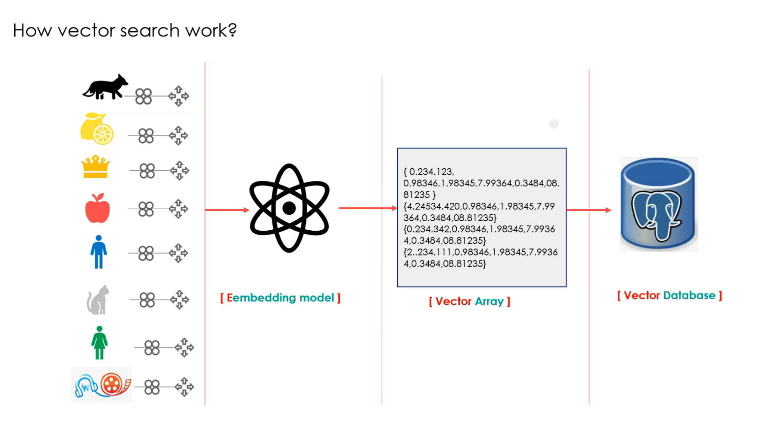

How does vector search work ?

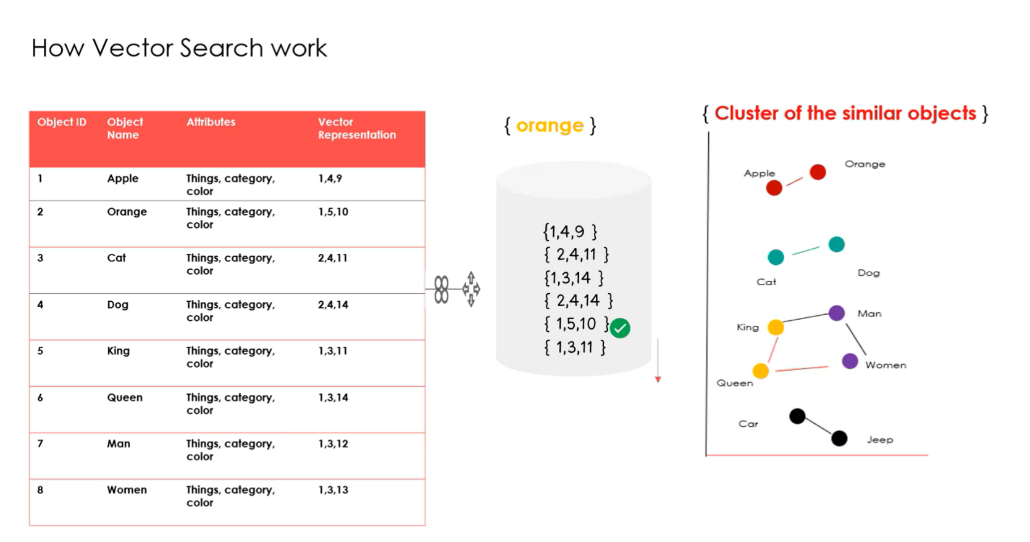

Vector similarty search

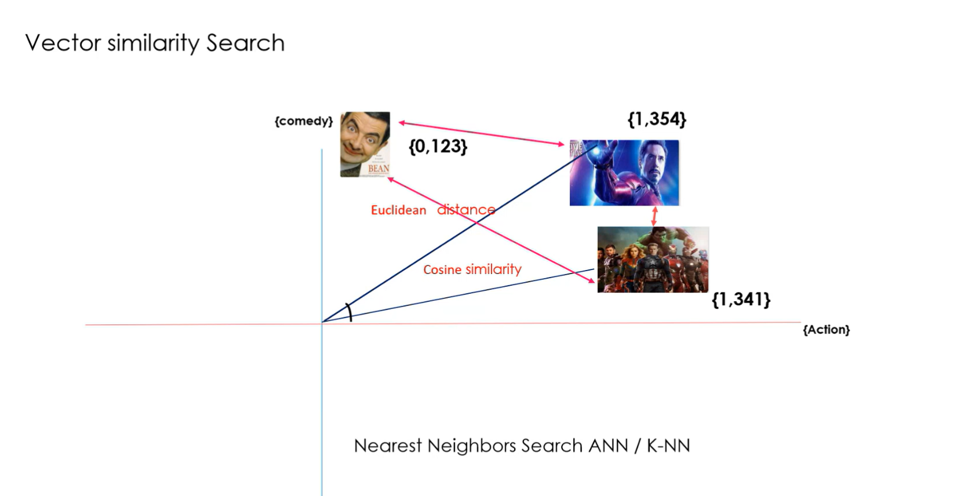

In day 1 most of vector bases and how the use in our coding to see and so many basic are covered.

Day 2
1. Install Python 3.12
Steps:
- Download Python 3.12:
  - Go to the official Python website.
  - Download the installer for version 3.12 suitable for your operating system (Windows/Mac/Linux).
- Install Python:
  - Run the downloaded installer.
  - Ensure you check the box "Add Python to PATH" during installation.
  - Verify the installation by running:
bash
Copy code
python --version
  - Output should confirm Python 3.12 is installed.

2. Install VS Code
Steps:
- Download VS Code:
  - Visit VS Code’s official website.
  - Download and install the editor for your operating system.
- Launch VS Code:
  - Open VS Code and explore the interface.
3. Install VS Code Python Extension
Steps:
- Open VS Code.
- Navigate to the Extensions View (Ctrl+Shift+X).
- Search for "Python".
- Click Install for the extension provided by Microsoft.
- Verify:
Open a Python file, and VS Code should suggest installing additional dependencies like the Python interpreter.

4. Install VS Code Jupyter Notebook Extension
Steps:
- Open the Extensions View (Ctrl+Shift+X).
- Search for "Jupyter".
- Install the extension.
- Verify:
Open a .ipynb file in VS Code, and it should launch the notebook interface.
5. Check Python System Environment Path
Verify Python PATH:
- Open a terminal or command prompt.
- Run:
bash
codeing:
echo %PATH% # Windows
echo $PATH # Mac/Linux
- Ensure the Python installation directory (e.g., C:\Python312\) is listed.
- If missing, add it manually:
On Windows:
    - Search for Environment Variables in the Start menu.
    - Edit the PATH variable and add Python’s installation path.
On Mac/Linux:
    - Add the following to ~/.bashrc or ~/.zshrc:
bash
code:
export PATH="$PATH:/path/to/python"
6. Install Ollama
Steps:
- Visit Ollama’s Documentation:
  - Depending on your system, find installation steps for Ollama.
  - Example (Mac/Linux):
bash
code:
curl -s https://ollama.ai/install.sh | bash
- Verify Installation:
  - Check the installation by running:
bash
code:
ollama --version
7. Download Llama3.2:3b Model
Steps:
- Ensure Ollama is Configured:
  - Confirm Ollama is running on your system.
- Download Model:
  - Use Ollama's CLI to download the model:
bash
code:
ollama pull llama3.2:3b
- Verify:
  - Check that the model is available in Ollama’s directory or cache.
8. Create a Repository (Local/Git)
Steps:
- Local Repository:
  - Create a new folder:
bash
Copy code
mkdir rag_project
cd rag_project
  - Initialize Git:
bash
code:
git init
- Create a Remote Git Repository:
  - Log into GitHub.
  - Create a new repository.
  - Link the local repository:
bash
code:
git remote add origin https://github.com/username/rag_project.git
9. Create a Python File for RAG Application
Steps:
- Create the Python File:
  - In the rag_project folder:
bash
Copy code
touch app.py
- Basic RAG Code Example:
python
code:
from transformers import AutoTokenizer, AutoModelForCausalLM
import torch
# Load Pre-trained LLM
model_name = "llama3.2:3b"
tokenizer = AutoTokenizer.from_pretrained(model_name)
model = AutoModelForCausalLM.from_pretrained(model_name)

# Retrieval-Augmented Generation Function
def retrieve_and_generate(query, knowledge_base):
# Step 1: Retrieve relevant context (simplified)
context = retrieve_context(query, knowledge_base)
# Step 2: Generate response using context
inputs = tokenizer(f"Context: {context}\nQuery: {query}", return_tensors="pt")
outputs = model.generate(**inputs)
return tokenizer.decode(outputs[0], skip_special_tokens=True)
# Example Usage
knowledge_base = ["Paris is the capital of France.", "The Eiffel Tower is in Paris."]
query = "What is the capital of France?"
print(retrieve_and_generate(query, knowledge_base))
- Run the Application:
  - Install required libraries:
bash
code:
pip install transformers torch
  - Run the script:
bash
code:
python app.py
final use
- Installed Python 3.12, VS Code, and required extensions.
- Verified environment setup and Python PATH.
- Installed Ollama and downloaded the Llama3.2:3b model.
- Created a Git repository and initialized a RAG application in Python.

Day 3

- Search Types in RAG:
In Retrieval-Augmented Generation (RAG), various search methods are employed to retrieve relevant data:
  - Similarity Search: Finds data points with vectors similar to the query vector, commonly used for semantic searches.
  - Cognitive Search: Incorporates AI to understand the query and retrieve relevant data contextually.
  - Keyword-Based Search: Retrieves data based on exact word matches in the query.

- What is an Index in a Vector Database?
An index in a vector database is a data structure that facilitates fast and efficient retrieval of vector data. It organizes the vectors for quick access during similarity searches or other operations. Examples include hierarchical navigable small-world graphs (HNSW) or approximate nearest neighbor (ANN) indices.

- Types of Databases:
  - SQL Databases: Used for structured data, represented in rows and columns, ideal for relational data models.
  - NoSQL Databases: Designed for unstructured or semi-structured data, often organized in collections or key-value pairs.

- How to Install a Package in Python:
  - Install: pip install <package_name>
  - Upgrade: pip install --upgrade <package_name>
  - Uninstall: pip uninstall <package_name>

- Models and LLMs:
  - Embedding Models: Tools like nomic-embed-text convert text into vector representations for tasks like similarity search.
  - LLMs (Large Language Models): Models such as Llama 3.2:3b interact with vectorized data to perform tasks like answering queries, summarization, or conversation
And the give some assignment for our learning there are

- Types of Indexes in Vector Databases:
Research and explain the various types of indexes used in vector databases (e.g., HNSW, IVF, Flat, or other nearest neighbor structures) that facilitate fast and efficient vector searches.

- Git Operations:
  - Create a new Git repository.
  - Clone the repository to VS Code.
  - Create a new branch from the main branch.
  - Add files and commit changes to the branch.
  - Merge the branch into the main branch and push the changes to the remote repository.

- Package vs. Library in Python:
Define and differentiate a "package" and a "library" in Python. A library typically refers to a collection of functions and classes to perform tasks, while a package is a collection of modules organized in a directory hierarchy with an __init__.py file.

- Retrievers in RAG:
  - Explain the role of retrievers in Retrieval-Augmented Generation (RAG). Retrievers fetch the most relevant data from external sources or databases to support the generation process.
  - Describe transformers as models used for various natural language processing (NLP) tasks. Discuss their ability to handle sequential data and parallelize operations, making them highly effective in tasks like translation, summarization, and question answering.

- Tokens and Tokenization:
  - Tokens are the smallest units of text (e.g., words, subwords, or characters) processed by NLP models.
  - Tokenization is the process of breaking text into these units for analysis or processing.

- Chains in RAG:
  - A chain in RAG refers to a sequence of operations or processes designed to handle specific tasks (e.g., retrieval, filtering, summarization).
  - Chains are used to organize and streamline workflows, making complex
tasks modular and easier to manage.
Day 4
Assignment
Introduction
Retrieval-Augmented Generation (RAG) combines the power of retrieval systems and generative models, enabling efficient information processing. Large Language Models (LLMs) play a crucial role in summarizing vector data retrieved during this process. This report explores how LLMs interact with vector databases, process retrieved data, and generate concise, context-aware summaries.
  - Understanding the Role of Vector Data in RAG
Vector data represents the numerical encoding of text or other modalities, allowing semantic comparisons using similarity measures. In RAG, vector data is typically retrieved based on its relevance to the input query. This is achieved through methods like similarity search or approximate nearest neighbor algorithms in vector databases.

2. How LLMs Summarize Vector Data
- Input Preparation:
The retrieved vector data is often associated with source content (e.g., documents, snippets). These sources are processed into a format the LLM can understand, such as raw text or structured metadata.
- Context Building:
LLMs use attention mechanisms to focus on the most relevant parts of the input data. They prioritize the content retrieved based on the input query while filtering redundant or irrelevant information.

Generation of Summaries:
LLMs generate summaries by:
  - Identifying key ideas or facts in the retrieved data.
  - Combining and rephrasing information to ensure clarity and coherence.
  - Maintaining contextual relevance to the original query.
The output is typically in natural language and can include direct answers, concise overviews, or elaborative summaries.

3. Techniques Used by LLMs for Summarization
- Fine-Tuned Models:
LLMs can be fine-tuned on summarization tasks using datasets that align with the RAG context, ensuring higher quality outputs.
- Prompt Engineering:
The structure and framing of prompts influence the LLM’s ability to summarize effectively. For example, providing instructions like "Summarize this article in three sentences" yields targeted results.
- Incorporating Metadata:
LLMs can leverage metadata (e.g., source reliability, recency) from the vector database to enhance the accuracy and relevance of summaries.

4. Benefits of Using LLMs for Summarization in RAG
- Efficiency: Reduces the cognitive load for users by extracting and presenting only the most relevant information.
- Scalability: Handles large volumes of data retrieved from vector databases.
- Contextual Awareness: Delivers nuanced summaries that align with the user’s query intent.

5. Challenges and Limitations
- Quality of Retrieved Data: The summarization is only as good as the quality of data retrieved by the vector database.
- Over-Summarization: Risk of losing critical details during compression.
- Computational Costs: Summarizing large datasets can be resource-intensive.

Conclusion
LLMs effectively bridge the gap between vector data retrieval and actionable insights in RAG workflows. By generating precise, context-rich summaries, they enable users to glean meaningful information from vast datasets quickly. Future advancements in LLM architectures and vector databases will further enhance the summarization capabilities, making RAG an even more powerful tool for information retrieval and knowledge generation.
Then the assigment was send to sir,After time to ask a viva question to me .
And file was send to ours to ask the viva the file is codeing to explain the process
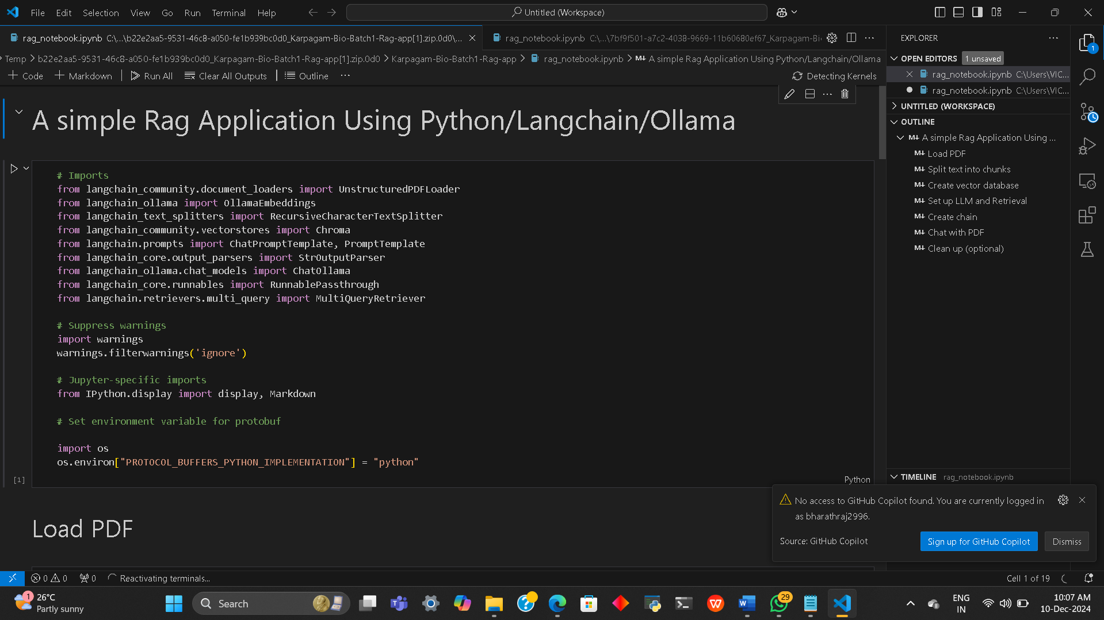

The program is importing in langchain in software was install then the run codeing is use of file reading

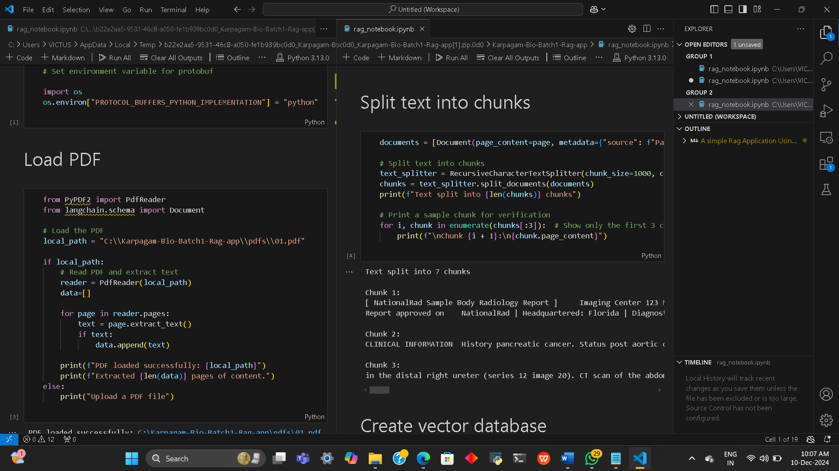

In more of coding is explain by step by step the full coding is not much but is easy to understand of using for how the coding is prossing to our pc and how the result be comeing to explain
Coding:
{
"cells": [
{
"cell_type": "markdown",
"metadata": {},
"source": [
"# A simple Rag Application Using Python/Langchain/Ollama "
]
},
{
"cell_type": "code",
"execution_count": 1,
"metadata": {},
"outputs": [],
"source": [
"# Imports\n",
"from langchain_community.document_loaders import UnstructuredPDFLoader\n",
"from langchain_ollama import OllamaEmbeddings\n",
"from langchain_text_splitters import RecursiveCharacterTextSplitter\n",
"from langchain_community.vectorstores import Chroma\n",
"from langchain.prompts import ChatPromptTemplate, PromptTemplate\n",
"from langchain_core.output_parsers import StrOutputParser\n",
"from langchain_ollama.chat_models import ChatOllama\n",
"from langchain_core.runnables import RunnablePassthrough\n",
"from langchain.retrievers.multi_query import MultiQueryRetriever\n",
"\n",
"# Suppress warnings\n",
"import warnings\n",
"warnings.filterwarnings('ignore')\n",
"\n",
"# Jupyter-specific imports\n",
"from IPython.display import display, Markdown\n",
"\n",
"# Set environment variable for protobuf\n",
"\n",
"import os\n",
"os.environ[\"PROTOCOL_BUFFERS_PYTHON_IMPLEMENTATION\"] = \"python\""
]
},
{
"cell_type": "markdown",
"metadata": {},
"source": [
"## Load PDF"
]
},
{
"cell_type": "code",
"execution_count": 3,
"metadata": {},
"outputs": [
{
"name": "stdout",
"output_type": "stream",
"text": [
"PDF loaded successfully: C:\\Karpagam-Bio-Batch1-Rag-app\\pdfs\\01.pdf\n",
"Extracted 2 pages of content.\n"
]
}
],
"source": [
"from PyPDF2 import PdfReader\n",
"from langchain.schema import Document\n",
"\n",
"# Load the PDF\n",
"local_path = \"C:\\\\Karpagam-Bio-Batch1-Rag-app\\\\pdfs\\\\01.pdf\"\n",
"\n",
"if local_path:\n",
" # Read PDF and extract text\n",
" reader = PdfReader(local_path)\n",
" data=[]\n",
"\n",
" for page in reader.pages:\n",
" text = page.extract_text()\n",
" if text:\n",
" data.append(text)\n",
"\n",
" print(f\"PDF loaded successfully: {local_path}\")\n",
" print(f\"Extracted {len(data)} pages of content.\")\n",
"else:\n",
" print(\"Upload a PDF file\")"
]
},
{
"cell_type": "markdown",
"metadata": {},
"source": [
"## Split text into chunks"
]
},
{
"cell_type": "code",
"execution_count": 4,
"metadata": {},
"outputs": [
{
"name": "stdout",
"output_type": "stream",
"text": [
"Text split into 7 chunks\n",
"\n",
"Chunk 1:\n",
"[ NationalRad Sample Body Radiology Report ] Imaging Center 123 Main Street Anywhere, USA 01234 Phone 123.456.7890 Fax 123.456.7890 PATIENT: JOHN SMITH DOB: 5/5/1955 FILE #: 12345 PHYSICIAN: REFERRING EXAM: MRI ABDOMEN WITH CONTRAST DATE: 1/1/2011 \n",
"Report approved on NationalRad | Headquartered: Florida | Diagnostic Imaging Services: Nationwide | 877.734.6674 | www.NationalRad.com\n",
"\n",
"Chunk 2:\n",
"CLINICAL INFORMATION History pancreatic cancer. Status post aortic chemotherapy and Whipple procedure on DATE. Chronic low back pain. Abdominal pain. Follow-up examination. COMPARISON Comparison is made with previous CT scan reported DATE and DATE CONTRAST 15 mL of MultiHance was administered per protocol. TECHNIQUE Coronal T2-weighted axial and T2; axial T2 fat sat clear, T2 and, T2 gradient-echo, and in phase sequences; dynamic axial T1 fat-sat post contrast additional subtraction reconstructions; coronal single shot MRCP sequences FINDINGS Marked hydronephrosis and hydroureter are present in the right kidney (series 12 images 19-27). Low signal intensity foci in the proximal right ureter (series 6 image 36) likely represents flow related artifact. Possible septations may be present in the distal right ureter (series 12 image 20). CT scan of the abdomen and pelvis with and without contrast is recommended to evaluate for possible stone or distal obstructing lesion. Findings\n",
"\n",
"Chunk 3:\n",
"in the distal right ureter (series 12 image 20). CT scan of the abdomen and pelvis with and without contrast is recommended to evaluate for possible stone or distal obstructing lesion. Findings are new since the previous examination. Decreased enhancement of the right kidney in comparison to the left during the\n"
]
}
],
"source": [
"documents = [Document(page_content=page, metadata={\"source\": f\"Page {i + 1}\"}) for i, page in enumerate(data)]\n",
"\n",
"# Split text into chunks\n",
"text_splitter = RecursiveCharacterTextSplitter(chunk_size=1000, chunk_overlap=200)\n",
"chunks = text_splitter.split_documents(documents)\n",
"print(f\"Text split into {len(chunks)} chunks\")\n",
"\n",
"# Print a sample chunk for verification\n",
"for i, chunk in enumerate(chunks[:3]): # Show only the first 3 chunks\n",
" print(f\"\\nChunk {i + 1}:\\n{chunk.page_content}\")"
]
},
{
"cell_type": "markdown",
"metadata": {},
"source": [
"## Create vector database"
]
},
{
"cell_type": "code",
"execution_count": 5,
"metadata": {},
"outputs": [
{
"name": "stdout",
"output_type": "stream",
"text": [
"Vector database created successfully\n"
]
}
],
"source": [
"# Create vector database\n",
"vector_db = Chroma.from_documents(\n",
" documents=chunks,\n",
" embedding=OllamaEmbeddings(model=\"nomic-embed-text\"),\n",
" collection_name=\"local-rag\"\n",
")\n",
"print(\"Vector database created successfully\")"
]
},
{
"cell_type": "markdown",
"metadata": {},
"source": [
"## Set up LLM and Retrieval"
]
},
{
"cell_type": "code",
"execution_count": 6,
"metadata": {},
"outputs": [],
"source": [
"# Set up LLM and retrieval\n",
"local_model = \"llama3.2:3b\" # or whichever model you prefer\n",
"llm = ChatOllama(model=local_model)"
]
},
{
"cell_type": "code",
"execution_count": 12,
"metadata": {},
"outputs": [],
"source": [
"# Query prompt template\n",
"QUERY_PROMPT = PromptTemplate(\n",
" input_variables=[\"question\"],\n",
" template=\"\"\"You are a medical Assistant Bot you need to clearly analyse the data\n",
" from the chunks retrived from the vector database and retrive chunks similar and \n",
" related to the question asked and also mainly tell if there are any abnormalities found \n",
" on the report and if any abnormality found please give a recommendataion to visit the\n",
" doctor clinic. Please note this is the question asked by user on web browser screen : {question}\"\"\",\n",
")\n",
"\n",
"# Set up retriever\n",
"retriever = MultiQueryRetriever.from_llm(\n",
" vector_db.as_retriever(), \n",
" llm,\n",
" prompt=QUERY_PROMPT\n",
")"
]
},
{
"cell_type": "markdown",
"metadata": {},
"source": [
"## Create chain"
]
},
{
"cell_type": "code",
"execution_count": 13,
"metadata": {},
"outputs": [],
"source": [
"# RAG prompt template\n",
"template = \"\"\"Answer the question based ONLY on the following context:\n",
"{context}\n",
"Question: {question}\n",
"\"\"\"\n",
"\n",
"prompt = ChatPromptTemplate.from_template(template)"
]
},
{
"cell_type": "code",
"execution_count": 14,
"metadata": {},
"outputs": [],
"source": [
"# Create chain\n",
"chain = (\n",
" {\"context\": retriever, \"question\": RunnablePassthrough()}\n",
" | prompt\n",
" | llm\n",
" | StrOutputParser()\n",
")"
]
},
{
"cell_type": "markdown",
"metadata": {},
"source": [
"## Chat with PDF"
]
},
{
"cell_type": "code",
"execution_count": 15,
"metadata": {},
"outputs": [],
"source": [
"def chat_with_pdf(question):\n",
" \"\"\"\n",
" Chat with the PDF using the RAG chain.\n",
" \"\"\"\n",
" return display(Markdown(chain.invoke(question)))"
]
},
{
"cell_type": "code",
"execution_count": 17,
"metadata": {},
"outputs": [
{
"data": {
"text/markdown": [
"The main idea of this document appears to be a radiology report from an MRI examination, specifically of the abdomen with contrast, performed on January 1, 2011. The report highlights various findings, including marked hydronephrosis and hydroureter in the right kidney, stable mild pelviectasis in the left kidney, postoperative changes from previous Whipple procedure, and other abdominal abnormalities. The report concludes with recommendations for further evaluation, such as a CT scan of the abdomen and pelvis with and without contrast."
],
"text/plain": [
"<IPython.core.display.Markdown object>"
]
},
"metadata": {},
"output_type": "display_data"
}
],
"source": [
"# Example 1\n",
"chat_with_pdf(\"What is the main idea of this document?\")"
]
},
{
"cell_type": "markdown",
"metadata": {},
"source": [
"## Clean up (optional)"
]
},
{
"cell_type": "code",
"execution_count": null,
"metadata": {},
"outputs": [
{
"name": "stdout",
"output_type": "stream",
"text": [
"Vector database deleted successfully\n"
]
}
],
"source": [
"# Optional: Clean up when done \n",
"vector_db.delete_collection()\n",
"print(\"Vector database deleted successfully\")"
]
}
],
"metadata": {
"kernelspec": {
"display_name": "Python 3",
"language": "python",
"name": "python3"
},
"language_info": {
"codemirror_mode": {
"name": "ipython",
"version": 3
},
"file_extension": ".py",
"mimetype": "text/x-python",
"name": "python",
"nbconvert_exporter": "python",
"pygments_lexer": "ipython3",
"version": "3.12.7"
}
},
"nbformat": 4,
"nbformat_minor": 2
}

Day 5

The rag in python was used so basic python was teach;

1. Printing and Commenting
- Use the print() function to display output.
- Comments (starting with #) are ignored by Python and used to explain code.
Example:
# This is a comment. It explains what the code does.
print("Hello, world!") # Prints a greeting to the screen
Output:
Hello, world!
2. Variables and Data Types
- Python automatically determines the type of a variable when you assign a value.
- Common types: int, float, str, bool.
Example:
age = 25 # int
pi = 3.14159 # float
name = "Alice" # str
is_student = True # bool

print(age, type(age)) # Output: 25 <class 'int'>
print(pi, type(pi)) # Output: 3.14159 <class 'float'>
print(name, type(name)) # Output: Alice <class 'str'>
print(is_student, type(is_student)) # Output: True <class 'bool'>

3. Arithmetic Operations
- Perform basic math using operators like +, -, *, /, and ** (power).
Example:
x = 10
y = 3

print(x + y) # Addition: 13
print(x - y) # Subtraction: 7
print(x * y) # Multiplication: 30
print(x / y) # Division: 3.3333333333333335
print(x ** y) # Exponentiation: 1000

4. String Manipulation
- Strings can be concatenated, repeated, or sliced.
Example:
greeting = "Hello"
name = "Alice"
print(greeting + ", " + name + "!") # Concatenation: Hello, Alice!
print(greeting * 3) # Repetition: HelloHelloHello
print(name[0:3]) # Slicing: Ali (first 3 characters)

5. Lists
- A list is a collection of elements that can be of mixed types.
Example:
fruits = ["apple", "banana", "cherry"]
fruits.append("orange") # Adding an element
print(fruits[1]) # Accessing an element: banana
print(fruits) # Output: ['apple', 'banana', 'cherry', 'orange']

6. Conditional Statements
- Use if, elif, and else for decision-making.
Example:
x = 10
if x > 5:
print("x is greater than 5")
elif x == 5:
print("x is equal to 5")
else:
print("x is less than 5")
Output:
x is greater than 5

7. Loops
- for loops are used for iteration, while while loops repeat as long as a condition is true.
Example (for loop):
for i in range(1, 6):
print(i) # Output: 1 2 3 4 5
Example (while loop):
count = 0
while count < 3:
print("Count:", count)
count += 1

8. Functions
- Reusable blocks of code defined with def.
Example:
def square(number):
return number ** 2

print(square(4)) # Output: 16

9. Error Handling
- Handle errors gracefully using try and except.
Example:
try:
result = 10 / 0
except ZeroDivisionError:
print("You can't divide by zero!")
Output:
You can't divide by zero!
10. Importing Modules
- Use import to include libraries.
Example:
import math
print(math.sqrt(16)) # Output: 4.0

Day 6

how to build a PDF-based Question Answering (QA) system using Streamlit, LangChain, and various NLP tools. Below is an explanation of the major components in the script:
  - Setting Up Streamlit
- Purpose: Provides a web interface for the application.
Code:
import streamlit as st
st.set_page_config(page_title="PDF QA with Ollama", layout="wide")
st.title("📄 PDF Upload and RAG Demo using Ollama")
Sets up the page layout and title for a user-friendly interface.
  - Includes sliders and text inputs for user-configurable options like chunk size, overlap, and model names.
  - User File Upload
Purpose: Accepts PDF files for processing.
- Code:
uploaded_file = st.file_uploader("Upload a PDF file", type="pdf")
if uploaded_file is not None:
with tempfile.NamedTemporaryFile(delete=False, suffix=".pdf") as tmp_file:
tmp_file.write(uploaded_file.read())
tmp_file_path = tmp_file.name
Lets users upload a PDF.
Temporarily saves the PDF for further processing.
PDF Loading and Splitting
Purpose: Extracts text content from the PDF and splits it into manageable chunks.
Code:
from langchain.document_loaders import PyPDFLoader
from langchain.text_splitter import RecursiveCharacterTextSplitter

loader = PyPDFLoader(tmp_file_path)
pages = loader.load_and_split()

text_splitter = RecursiveCharacterTextSplitter(
chunk_size=chunk_size,
chunk_overlap=chunk_overlap,
length_function=len,
)
texts = text_splitter.split_documents(pages)
  - PyPDFLoader reads the PDF and parses its pages into text.
  - RecursiveCharacterTextSplitter breaks text into chunks of specified size for effective processing.
  - Creating Embeddings
- Purpose: Converts text into numerical representations (vectors) for similarity matching.
- Code:
from langchain.embeddings import HuggingFaceEmbeddings
from langchain.vectorstores import FAISS

embeddings = HuggingFaceEmbeddings(model_name=embedding_model)
docsearch = FAISS.from_documents(texts, embeddings)
HuggingFaceEmbeddings creates embeddings using a specified model.
FAISS stores these embeddings for fast similarity searches.

Setting Up the Retrieval-Augmented Generation (RAG) Chain
Purpose: Combines a retriever with a large language model (LLM) to generate answers.
Code:
from langchain.chains import RetrievalQA
from langchain.llms import Ollama

retriever = docsearch.as_retriever()
llm = Ollama(model=ollama_model)
qa_chain = RetrievalQA.from_chain_type(
llm=llm,
chain_type="stuff",
retriever=retriever,
)
  - Retriever finds relevant chunks from the document using FAISS.
  - Ollama LLM processes these chunks to generate answers.
  - RetrievalQA orchestrates the retrieval and generation steps.

- Purpose: Takes user questions and provides answers.
- Code:
user_question = st.text_input("Ask a question about the PDF content:")
if user_question:
answer = qa_chain.run(user_question)
st.write("### Answer:")
st.write(answer)
  - Accepts user queries about the PDF.
  - Sends queries to the RAG chain for answers and displays the results.

Error Handling
- Purpose: Ensures smooth user experience by catching errors.
- Code:
# Processing logic
except Exception as e:
st.error(f"🚨 An error occurred: {e}"
os.unlink(tmp_file_path
Catches and displays errors in case of issues during processing.

Works
- The user uploads a PDF.
- The PDF's text content is extracted and split into chunks.
- Text chunks are converted into embeddings using a Hugging Face model.
- A FAISS-based retriever identifies relevant chunks for a user's query.
- The Ollama LLM generates answers based on these chunks.
- Answers are displayed on the Streamlit interface.
Day 7
It looks like you're asking about Google Colab—a free, browser-based Python environment provided by Google. Here's an overview of Google Colab and how it can be useful for running Python code, including the example you shared.

What is Google Colab?
- Cloud-based Jupyter Notebook: Google Colab provides a cloud-based environment for running Jupyter Notebook-style Python scripts without requiring any setup.
- Free GPUs/TPUs: Colab includes free access to GPUs and TPUs for machine learning tasks.
- Integration with Google Drive: Allows you to save and access notebooks and files directly from your Google Drive

How to Use Google Colab?
- Access Colab:
  - Go to Google Colab.
  - Sign in with your Google account.
- Create a New Notebook:
  - Click on "New Notebook" to start coding.
- Code Execution:
  - Code cells can be run by clicking the play button (▶) or pressing Shift + Enter.
- Install Libraries:
  - Use !pip install <package> to install libraries directly in Colab.
Running the PDF QA Script in Colab
To run your Streamlit-based script in Google Colab, you need to adapt it slightly since Streamlit apps are designed to run in a web server, not directly in a notebook. Here's a step-by-step guide:

Step 1: Install Required Libraries
Run the following in a Colab code cell to install the necessary libraries:
!pip install streamlit PyPDF2 langchain huggingface-hub sentence-transformers faiss-cpu

Step 2: Modify the Script
Streamlit doesn't run natively in Colab notebooks. Instead, you can:
- Save your script as a Python file (app.py).
- Run it using !streamlit run app.py.
For your script:
- Copy it into a cell in Colab.
- Save it to a file:
- script = """
- # Paste your script here
- """
- with open("app.py", "w") as file:
- file.write(script)

Step 3: Run the App
Run the app in Colab using:
!streamlit run app.py & npx localtunnel --port 8501
- localtunnel creates a public URL to access your Streamlit app.
- Follow the link generated in the output.
Limitations of Colab for Streamlit
- Google Colab isn’t designed for interactive web apps like Streamlit.
- For the best experience, consider running your Streamlit app locally or deploying it to a platform like:
  - Streamlit Cloud
  - AWS
  - Google Cloud

Day 7
Mermaid :
Mermaid is used to create diagrams and visualizations directly from plain text.
User Query Workflow (PDF QA System)
graph TD
A[User Input: Question] --> B[Step 1: Preprocess the Question]
B --> C[Step 2: Convert Question to Embedding]
C -->|Module: OllamaEmbeddings| D[Step 3: Retrieve Relevant Chunks]
D -->|Module: Vectorstore Retriever| E[Step 4: Pass Chunks and Question to LLM Chain]
E --> F[Step 5: Invoke LLM for Final Response]
F -->|Module: Ollama LLM API| G[Step 6: Generate Final Response]
G --> H[Step 7: Provide Response to User]
Description:
A: The user inputs a question via the application.
B: Preprocess the question to ensure it is suitable for embedding generation (e.g., tokenizing, removing noise).
C: Convert the user question into an embedding using OllamaEmbeddings.
D: Use a Vectorstore Retriever to find document chunks that are most relevant to the question.
E: Combine the question and the retrieved chunks and pass them to the LLM chain for reasoning.
F: Invoke the Ollama LLM API to generate a coherent response.
G: The response is processed and finalized.
H: Provide the response back to the user through the application interface.
Document Processing Workflow
A[Start: Load PDF Document] --> B[Step 1: Read the PDF using a Loader]
B --> C[Step 2: Parse and Extract Text Content]
C --> D[Step 3: Split Document into Chunks]
D --> E[Step 4: Configure Chunking Parameters such as Size and Overlap]
E --> F[Step 5: Convert Text to Embeddings]
F --> G[Step 6: Create Vector Database]
G --> H[Step 7: Store Embeddings in Vector Database]
H --> I[Step 8: Set up Retrieval Logic]
I --> J[Step 9: Configure Ollama LLM for Querying]
J --> K[Step 10: Query LLM with User Input]
K --> L[Step 11: Retrieve Relevant Chunks from Vector Database]
L --> M[Step 12: Use LLM to Generate a Final Response]
M --> N[End: Provide Generated Output to User]
Description:
A: Begin by loading the PDF document using a PDF loader.
B: Read the PDF file to parse its structure and extract raw text.
C: Split the text content into smaller, manageable chunks for processing.
D: Configure the chunking parameters, such as chunk size and overlap, for optimal retrieval performance.
E: Convert the chunks into embeddings using a pre-trained model (e.g., HuggingFace or Ollama embeddings).
F: Create a vector database to store the embeddings for fast retrieval.
G: Store the embeddings in the vector database (e.g., FAISS).
H: Implement logic to retrieve relevant chunks based on similarity to user input.
I: Configure the Ollama LLM to interact with the retrieval logic and process questions.
J: Accept user input (a query) to initialize the querying process.
K: Use the vector database to find the most relevant chunks matching the query.
L: Pass the chunks and query to the LLM to generate a detailed response.
M: The LLM generates the final response based on the chunks and query context.
N: Output the final response to the user.

Day 8
Purpose of the Project
The PDF QA System with Ollama and LangChain enables users to interactively ask questions about the content of a PDF document. It combines advanced natural language processing capabilities with information retrieval techniques to provide accurate and context-aware answers. The primary purpose of the project is to extract information from uploaded PDFs and answer user queries based on the content.
1. PDF Parsing: Extracts and processes text from uploaded PDF files.
2. Document Chunking: Splits PDF content into manageable chunks for better analysis.
3. Embeddings Creation: Converts text into embeddings using HuggingFace models.
4. Retrieval-Augmented Generation (RAG): Combines document retrieval with a language model to generate answers.
5. Interactive Web Interface: Built using Streamlit for a user-friendly experience.
System Workflow
1. PDF Upload: Users upload a PDF document through the web interface.
2. Text Extraction: The system reads and extracts text content from the PDF.
3. Text Chunking: Content is split into smaller pieces to enable precise retrieval.
4. Embedding Generation: Each text chunk is converted into vector embeddings.
5. Query Processing: User questions are processed and converted into embeddings.
6. Relevant Content Retrieval: The system retrieves text chunks similar to the user’s query.
7. Answer Generation: The retrieved content and query are passed to the LLM to generate a detailed response.
Technologies Used
1. Streamlit: For building the web interface.
2. LangChain: Framework for chaining components like retrievers and LLMs.
3. FAISS: Library for efficient similarity search.
4. HuggingFace Embeddings: For creating vector representations of text.
5. Ollama LLM: A locally deployed language model for generating responses.

Day 9
1. Create the Streamlit Application
- Code Example: Create a Python script, e.g., app.py, and use Streamlit to define the interface and functionality.
- import streamlit as st
- st.title("My Streamlit App")
- st.write("Welcome to my Streamlit application!")
2. Test the Application Locally
- To run the Streamlit app locally, open the terminal and navigate to the folder where your app.py is located. Then run:
- streamlit run app.py
The app will start and should be accessible at http://localhost:8501 by default.

3. Document Your Project
README.md File
Your project’s documentation should be contained in a README.md file that helps users understand your project:
Example README.md:
# My Streamlit App

overview
This app visualizes data interactively using Streamlit. It is designed to provide a simple interface for exploring various data sets and performing data analysis.

- Interactive data visualizations
- Real-time data processing
- User-friendly interface
Setup
1. Clone the repository:
```bash
git clone <repository-url>
cd <repository-folder>
- Install dependencies:
  - Create a requirements.txt file (explained below) and install the dependencies:
  - pip install -r requirements.txt
- Run the app:
- streamlit run app.py
Usage
Once the app is running, open your browser and go to the URL displayed in the terminal (http://localhost:8501 by default). You can interact with the app to explore the data.
Code Documentation
Each function in the code includes docstrings and comments explaining its purpose and usage.

4. Deployment
Once the app is running locally and you’re satisfied with its functionality, it’s time to deploy it so others can access it.
Deploying to Streamlit Cloud (formerly Streamlit Sharing):
- Push your project to GitHub:
  - Ensure your GitHub repository includes:
    - app.py (the main Streamlit application script)
    - requirements.txt (list of dependencies)
    - README.md (project documentation)
- Create requirements.txt: This file contains all the dependencies required to run the app. Example:
- streamlit
- pandas
- matplotlib
You can generate it automatically by running:
pip freeze > requirements.txt
- Deploy to Streamlit Cloud:
  - Visit Streamlit Cloud and sign in with your GitHub account.
  - Link your GitHub repository.
  - Select the branch and entry point (i.e., app.py).
  - Deploy the app.
Other Deployment Options:
- Heroku:
  - Use a Procfile:
  - web: streamlit run app.py --server.port=$PORT
  - Deploy via Heroku CLI:
  - git push heroku master
- Docker:
  - Create a Dockerfile:
  - FROM python:3.9
  - WORKDIR /app
  - COPY . .
  - RUN pip install -r requirements.txt
  - EXPOSE 8501
  - CMD ["streamlit", "run", "app.py", "--server.port=8501", "--server.enableCORS=false"]
  - Build and run the Docker image:
  - docker build -t streamlit-app .
  - docker run -p 8501:8501 streamlit-app

5. Maintain Documentation
- Update README.md: Make sure to include deployment instructions and any relevant details for contributors.
- CHANGELOG.md: Track changes in the project with a changelog file to help users and collaborators stay updated.
- Create the app: Write your app’s code and test it locally.
- Document the project: Ensure you have a README.md file that describes the project and its usage.
- Deploy: Make your app available on platforms like Streamlit Cloud, Heroku, or Docker.
- Maintain documentation: Keep everything updated with changes and instructions for users and developers.

Day 10
Github to project uplode

Uploading your project to GitHub allows you to share your work, collaborate with others, and keep your code safe and accessible. Here is a step-by-step guide to help you upload your project to GitHub.
Step 1: Create a New Repository on GitHub
- Sign in to GitHub: Go to GitHub and sign in to your account.
- Create a New Repository: Click on the "+" icon in the upper-right corner and select "New repository".
- Repository Details: Enter a name for your repository, add a description, and choose the visibility (Public or Private). Optionally, you can initialize the repository with a README file.
- Create Repository: Click on "Create repository" to finalize the creation.
Step 2: Initialize Git in Your Project Folder
- Open Terminal: Navigate to the root directory of your project using the terminal.
- Initialize Git: Run the following command to initialize a Git repository in your project folder: git init
- Add Files to Git: Add all your project files to the Git index using: git add
- Commit Changes: Commit the added files with a message: git commit -m "Initial commit"
Step 3: Link Your Local Repository to GitHub
- Add Remote Repository: Link your local repository to the GitHub repository you created by running: git remote add origin https://github.com/your-username/your-repository-name.git Replace your-username and your-repository-name with your GitHub username and repository name.
Step 4: Push Your Project to GitHub
- Push to GitHub: Push your local repository to GitHub using: git push -u origin main This command sets the remote repository as the upstream reference and pushes your code to the main branch.
Step 5: Verify Your Project on GitHub
- Check Repository: Go to your GitHub repository URL and verify that your project files have been uploaded successfully
My project uplode link in github : https://github.com/bharathraj2996/chatbot.git

